[All Rights Reserved]

SLIATE

**SLIATE**

###### **SRI LANKA INSTITUTE OF ADVANCED TECHNOLOGICAL EDUCATION**

**(Established in the Ministry of Higher Education, vide in Act No. 29 of 1995)**

**Higher National Diploma in Information Technology**

**First Year, First Semester Examination – 2018**

**HNDIT 1105 – Database Management Systems**

Instructions: No. of questions : 05

Answer any Four Questions. No. of pages : 05

Every Questions carry 25 Marks. Time :02 hours

* 1. Define or explain following terms.
     1. Data (02 Marks)
     2. Information (02 Marks)
     3. Data processing (02 Marks)
     4. Meta Data (02 Marks)
     5. Database (02 Marks)
     6. DBMS (02 Marks)
     7. Data Abstraction (02 Marks)
  2. Explain the use of *user query* in DBMS? (03 Marks)
  3. List four (04) main Characteristics of the Database Approach. (04 Marks)
  4. Compare the models of databases named ***Hierarchical*** and ***Network***.

(04 Marks)

(Total 25Marks)

* 1. List five (04) examples of DBMS software except *MS Access*. (04 Marks)
  2. Briefly explain the followings in MS Access.
     1. Referential integrity.
     2. Cascade update related fields.
     3. Cascade delete related records. (06 Marks)
  3. Briefly explain four (04) database issues. (04 Marks)
  4. Explain the five component of DBMS environment with diagram. (06 Marks)
  5. Define the term Data Redundancy. (04 Marks)

(Total 25Marks)

* 1. List four object types in MS Access. (04 Marks)
  2. Fill in the following table for data type and attribute type.

(08 Marks)

|  |  |  |
| --- | --- | --- |
| Attribute Name | MS Access Data Type | Attribute Type |
| CustomerID |  |  |
| Address |  |  |
| Phone Number |  |  |
| Age |  |  |

* 1. Briefly explain the following terms in Entity Relationship modelling. (03Marks)
     1. Entity
     2. Relationship
     3. Attribute
  2. Draw the notation for the following with appropriate example. (06Marks)
     1. Composite attributes
     2. Multivalued attributes
     3. Derived attribute
  3. Explain the advantages of Entity Relationship modal. (01Marks)

(Total 25Marks)

* 1. Consider the following many-to-many relationship.

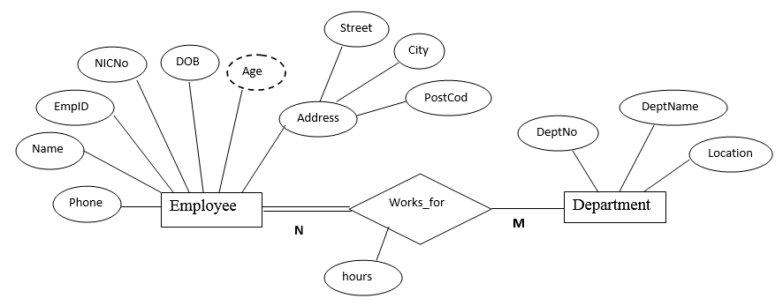

* + 1. Identify the composite, derived, key, and descriptive attributes (04 Marks)
    2. Identify a possible multivalued attribute. (01 Mark)
    3. Convert the above ERD into relational schema. (05 Marks)
  1. Consider the following scenario which prepared to construct a relational database. Draw the ER diagram. (Mention Entities, relationships, cardinalities, and totality/partiality clearly in the ER diagram).
* In a technological University, there are several departments and students belong to one of them. Each department has a unique department number, a name, a location, phone number and is headed by a professor.
* Professors have a unique employee ID, name, phone number. We like to keep track of the following details regarding students: name, unique role number, sex, phone number, date of birth, age and one or more email address.
* Students have a local address consulting of the hostel name and the room number. They also have home address consisting of house number, street, city and PIN. it is assumed that all students reside in the hostels.
* A course taught in a semester of the year is called a section. There can be several sections of the same course in a semester. These are identified by the section number. Each section has its own time and a lecture room to conduct.
* Students enroll for several sections in a semester. Each course has a name, number of credits and the department that offers it. A course may have other courses as prerequisites i.e., courses to be completed before it can be enrolled in.
* Professors also undertake research projects. These projects are sponsored by funding agents and have a specific start date, end date and amount of fund given. More than one professor can be involved in a project. Also a professor may be simultaneously working on several projects. A project has a unique project ID.

(15 Marks)

(Total 25 Marks)

* 1. Explain the following DBMS language. (04 Marks)
     1. DCL
     2. TCL
     3. DML
     4. DDL
  2. What is the functionality of the following SQL command? (02Marks)
     1. UPDATE
     2. INSERT
     3. SELECT
     4. DELETE
  3. Following table gives the information about employee database.

Employee

|  |  |  |  |  |
| --- | --- | --- | --- | --- |
| **Eno** | Ename | Egender | Eaddress | Esalary (Rs.) |
| e1 | Maryam | F | Colombo | 50000 |
| e2 | Kamal | M | Kandy | 40000 |
| e3 | Sampath | M | Ampara | 30000 |
| e4 | Jagadeeshwar | M | Colombo | 37000 |

Department

|  |  |  |
| --- | --- | --- |
| **Dno** | Dname | Head |
| D001 | IT | e1 |
| D002 | Accounts | e7 |
| D003 | Admin | e8 |
| D004 | Marketing | e2 |

Write the SQL statement to perform the following

* + 1. Insert the following details in to Employee table. (02Marks)

Eno-e5 Eaddress – Colombo

Ename-Alex Esalary -35000

Egender –M

* + 1. Display number and name of all employee’s. (02Marks)
    2. Display the name of the female (F) employee’s. (02Marks)
    3. Display the number and salary of employee whose name starts with M. (02Marks)
    4. Display all records who drawn salary between 25000 and 45000 (02 Marks)
    5. Display employee address who manages marketing department (02 Marks)
    6. Create the above table. (02 Marks)
    7. To increase salary by 20%. (02 Marks)

(Total 25 Marks)

* 1. Briefly explain the following terms with appropriate example per each. (09 Marks)
     1. Transitive dependency
     2. Partial dependency
  2. Write down three (03) rules to satisfy the first Normal Form (1NF) standard.

(03Marks)

* 1. Briefly explain the following terms. (06 Marks)
     1. 1st Normal Form
     2. 2nd Normal Form
     3. 3rd Normal Form
  2. Convert the following table UNF to 1NF. (05 Marks)

|  |  |  |
| --- | --- | --- |
| Student no | name | subject |
| 121 | Sajeer | C,C++ |
| 122 | Nimal | Java |
| 123 | Ayies | VB, Java |
| 124 | Buddika | OS,CN |

* 1. List 02 advantage of normalizing. (02 Marks)

(Total 25Marks)